- Purpose
  - The purpose of this document is to describe the procedure for assembling a Kawasaki engine.
- Scope
  - This SOP applies to all equipment assembly team members. The process applies to the following machines:
E012800EQM0600BE1200 – 21” Optima XR
E012805EQM0600BE1200 – 21” Optima XR w/ Clutch
E012815EQM0600BE1200 – 21” Optima XR w/ Emissions & Clutch
E012830EQM0600BE1200 – 27” Optima XR
E012835EQM0600BE1200 – 27” Optima XR w/ Clutch
E012840EQM0600BE1200 – 27” Optima XR w/ Emissions
E012850EQM0600BE1200 – 27” Optima XR w/ Dust Control
E012860EQM0600BE1200 – 27” Optima XR w/ Clutch & Dust Control
E012865EQM0600BE1200 – 27” Optima XR w/ Emissions & Dust Control
E012875EQM0600BE1200 – 27” Optima XR w/ Emissions, Clutch, & Dust Control
E012327EQM0600BE1200 – Big Bertha XSM30 Propane Stripping Machine Pkg
E088398EQM0600BE1200 – Lil Bertha XSM24 Propane Stripping Machine Package
- Responsibilities
  - The operations manager/supervisor is responsible for enforcing this SOP.
- Materials
  - The proper materials needed for this process are listed on the sub-assembly work order.
- Definitions

- Procedure
  - Take an engine (84699) from the packaging.
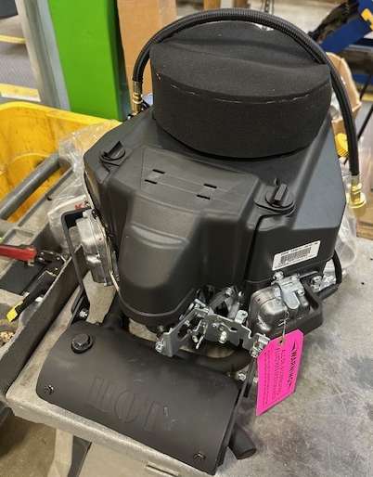

  - Put a Caution Oil Pressure Switch decal (10549) onto the motor in the location shown.
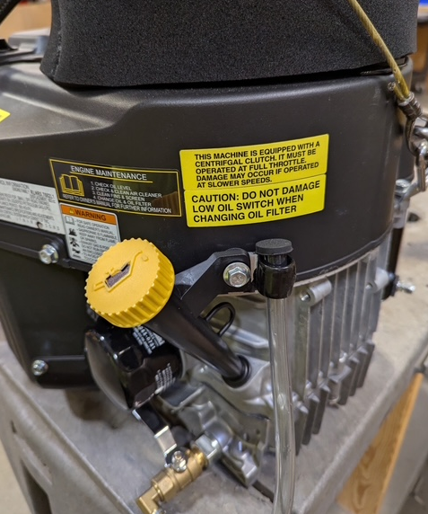
  - Place a Betco sticker (88482) onto the proper location on the air filter cover.

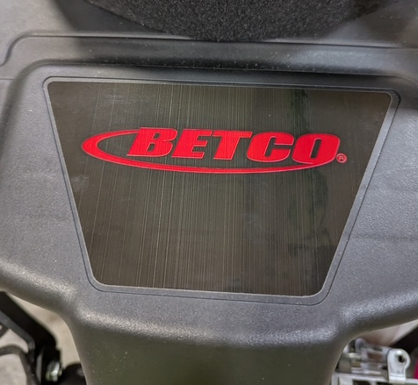

  - Place a “Read Owners Manual” decal (10545) at the location shown below.
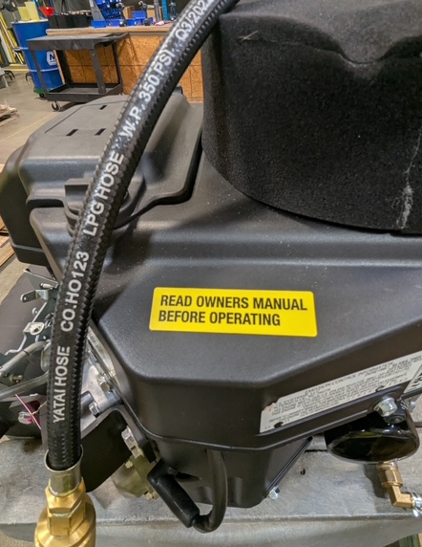

If the engine is to be equipped with an emissions monitor, proceed to step 6.5. If the engine is to be equipped with a centrifugal clutch, proceed to step 6.7. If the engine does not have a clutch or an emissions monitor, assembly is complete.

  - Remove the bolt (3/4” Socket) that is located in the emissions port on the muffler. In it, thread the emissions probe (80142) with a 7/8” wrench. Put some anti-seize on the threads of the sensor first.
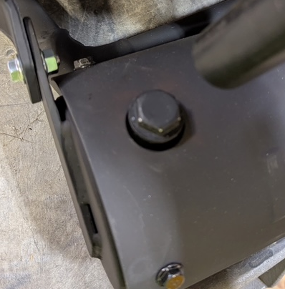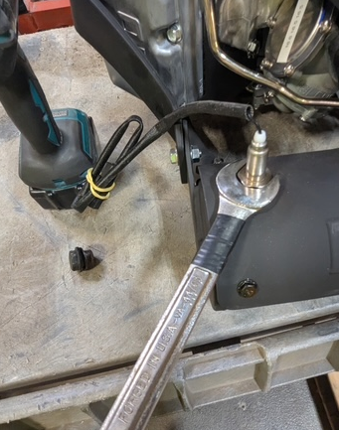
  - On the plastic motor cover, in the location shown, fasten the emissions monitor (80141). This is done using 2 screws (11321). On the monitor, cut off the flag terminal and replace it with an E12254 terminal.

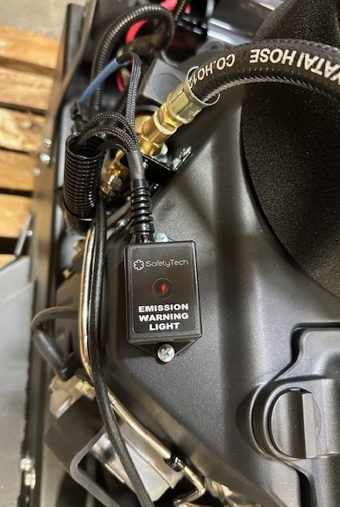
If the engine is to be equipped with a centrifugal clutch, proceed to the item below.
  - Place a Centrifugal Clutch decal (10544) onto the engine in the location shown.
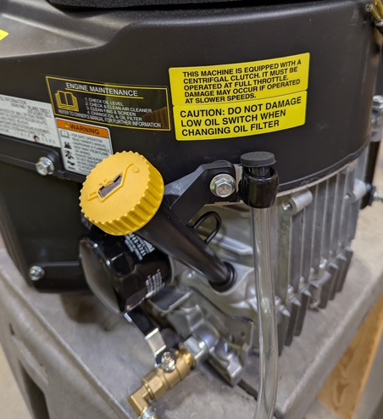
- References (optional section as needed)

- Training Guide

Functional Training Groups Requiring Training
Equipment Assembly Group

- SOP Change Control

Date of Change | Reason for Change
Rev 01 - 11/22/2013 | This is the first version of the S.O.P. hence there are no revisions to this document.
Rev 02 - 1/15/2018 | Added the Responsibilities sections and updated the rivets on the intake guard
Rev 03 - 5/4/2018 | Updated with the New Optima XR machine ID’s. Updated with the new engine setup instructions for the XR model.
Rev 04 - 1/15/2019 | Updated with 2019 Emissions certification decal part number change.
Rev 05 - 3/18/2025 | Updated for Onyx engine
Rev 06 – 11/17/2025 | Updated machine ID’s in Scope 2.01. Added terminal update on the emissions box

Approvals
Submitter/Author Approval: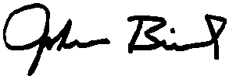 Date: 1/15/2019
Management Approval: Date: 1/15/2019
QAU Approval:  Date: 1/15/2019

